**2 weeks**

**100 regression (manual testing 30 mins)**

**People required for executing 100 testcases in 10 days (5 persons)**

**Selenium is an open-source tool** that automates web browsers. It provides a single interface that lets you write test scripts in programming languages like Ruby, Java, NodeJS, PHP, Perl, Python, and C#, among others.

**Introduction:**

Selenium is an open source automation testing tool.

It is used exclusively for web based applications

You can work on multiple operating systems using selenium

* Platforms Supported by Selenium
* Windows
* OS X
* Linux
* Solaris

**Following languages are used with selenium.**

* Java
* C#
* Ruby
* Pyton
* PHP
* Pearl

**Selenium Browsers Support:**

* Internet Explorer
* Firefox
* Chrome
* Safari
* Edge browser

**Interview Questions**

1. What makes Selenium Unique from other Automation tools?

Before selenium came into market we had QTP/UFT

1. Explain WebDriver Architecture.
2. Why not older Version Selenium RC 1.0?
3. What are different Versions of Selenium?
4. What are different browsers does Webdriver Support?
5. In how many languages we can write Selenium code?

**\*\*Selenium Features\*\***

* Selenium is open Source Automation Testing tool
* It is exclusively for Web Based applications.
* Selenium supports multiple browsers -   
  Chrome, Firefox, Internet Explorer, Safari
* Selenium works with Multiple Platforms   
  Windows, Apple OS X, Linux
* Selenium can be coded in multiple languages -   
   Java, C#, Python, Javascript, Python, php,Ruby
* Difference between Selenium and Webdriver?

Selenium is a pack of tools:

Ide

Webdriver

GridT

**Steps to follow to install and Selenium :**

1. **Install Java**
2. **Setup Java home(Java path) in System Variables**

* Right Click on **This PC**
* Click on **Properties**
* Click on Advanced system settings
* Click on Environment variables(present at the end)
* Click on New button present under system variables section
* Enter Variable name as **“JAVA_HOME”**
* **For Variable value follow below:**
* Go to this path : **C:\Program Files\Java**
* We should see both jdk and jre folders
* Get into JDK folder
* Copy folder path and enter in Variable value field
* Click OK
* **Follow below for setting up PATH:**
* Select **Path** option available from the system variables section and click on **edit**
* Click on **new** button in edit environment variables popup and enter this path : %JAVA_HOME%\bin
* Click on **OK, OK, OK**

1. **Install Eclipse (editor) (Eclipse IDE for Java Developers)**
2. **Create a sample project (Maven with selenium dependencies)**

Selenium WebDriver Architectue Simplified:

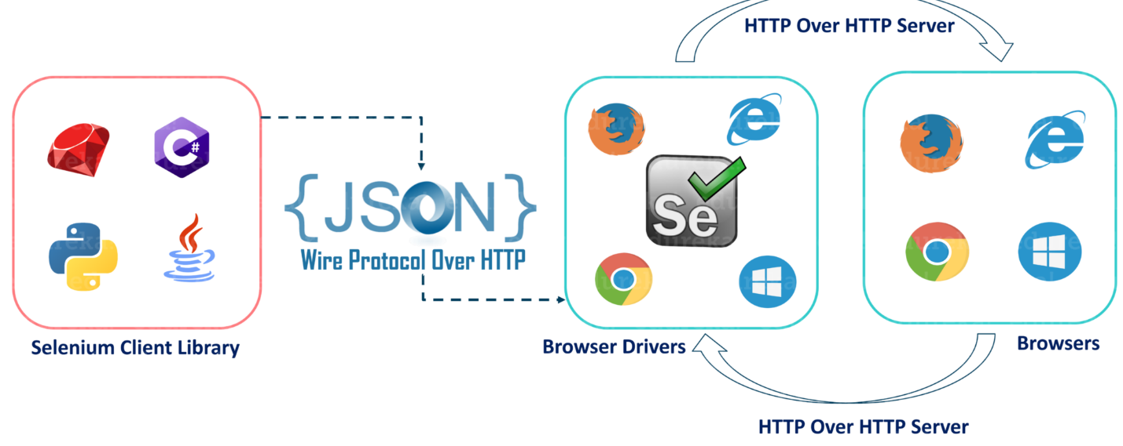

* After you trigger the Test, complete Selenium code (Client) which we have written will be converted to Json format
* Generated Json is sent to Browser Driver (Server) through http Protocol

Note: Each browser contains a separate browser driver

* . Browser drivers communicate with its respective browser and executes the commands by interpreting Json which It received on the browser.
* Browser Driver receives responses back from the browser and it sends Json response back to Client.

Creating a sample project:

1. Create a maven project
2. Open pom.xml file and add selenium java dependency in there, click save
3. You should see Maven Dependency folder created in your project
4. Instantiate driver with the below code:

**System.*setProperty*("webdriver.chrome.driver", "Path of chromedriver.exe file");**

**JAVA_HOME C:\Program Files\Java\jdk1.8.0_341**

**WebDriver driver = new ChromeDriver(); (driver as object or reference variable)**

**Cross Browser Testing**